Contents

Page | Title
1 | Access the Supplier Self Service Portal  How to log into the Supplier Self Service Portal
2 | Access the e-Payables (BI) reports in the Supplier Self Service Portal  How to access e-Payables reports in the Portal, enter information to restrict the report data and then run the reports
8 | Tables of Prompts used to restrict the data in the reports  A list of the Prompts available in each report, used to restrict the data. Definitions and examples are provided.
11 | Navigate the e-Payables (BI) reports in the Supplier Self Service Portal  When you have run the report, learn how to add additional filters, print, export and save the information.
15 | Tables of the column headings and definitions used in the reports  A list of the column headings displayed in each report. Definitions are provided for clarification

Purpose
Complete these steps to log in to the Supplier Self Service Portal, where you can then access the e-Payables (BI) reports.
NOTE: To access the reports, you must have requested the Accounting Information (BI) service package as part of your Supplier access. Please refer to the front page of the supplier portal, after logging in, if you need to request additional access.
The JLR Supplier Portal will be integrated into Covisint for single sign on. Once logged onto Covisint, the JLR Supplier Portal will be available as a link under Covisint Applications.

Step | Action
1 | Access Covisint via the following link: https://jlr.portal.covisint.com/web/portal/
2 | Complete the following fields as required:  Field R/O/C Enter  User ID? R Your user name for accessing Covisint  Password? R Memorable password assigned to the user account
3 | Click

Purpose
Complete these steps to access e-Payables reports in the Supplier Self Service Portal.
The reports available are:
- Debit Note Report – details any debit notes raised against a vendor’s account, including date, amount and debit note number
- Invoices Ready for Payment (was previously SRM Outstanding Payment History) – details any outstanding payments. Includes details of the vendor invoice number and date raised, JLR’s invoice document number, payment due date and payment amount in both local and document currency. Report is split into two:
  - Summary of invoices-Ready for Payment (was previously Total Outstanding Summary)
  - Details of Invoices-Ready for Payment (was previously Details of Outstanding Payments)
- Payment History Report (was previously SRM Payment History Report) – details any payments that have already been made. Includes details of JLR’s Payment document number, payment date, amount paid and currency. Report is split into two:
  - Paid Invoices (was previously Payment history Report)
  - Details of Paid Invoices (was previously Detailed Payment)
- Invoices Pending-In progress – details any outstanding invoices. Includes details of the vendor invoice number and date raised, JLR’s invoice document number, payment due date and payment amount in both local and document currency.

NOTE: In order to access these reports, you must have requested the Accounting Information (BI) service package as part of your Supplier access. Please refer to the front page of the supplier portal if you need to request additional access.

Step | Action
1 | After logging in to the Supplier Self Service Portal, review the My Applications area on the Home page.
2 | Click on Accounting Information BI in the My Applications area to access the reports.
3 | Ensure the tab is selected to view the available reports.  The navigation pane on the left of the screen displays the reports that are available to select:
4 | Click on a report title in the Navigation pane to open it, e.g. Invoice Ready For Payment.
5 | The Prompts screen is displayed.  The Prompt options on the left of the screen allow you to restrict the report data to include or exclude specific information.  Some Prompts are mandatory and these are already completed with example data. In this example, Due Date 1 and Due Date 2 are already completed and should be changed to meet your requirements.  (Please refer to the tables at the end of this document for definitions of the Prompts in each of the reports)
6 | Select an action from the following:  If … then …  You want to update a Date Prompt Click on the relevant Prompt on the left of the screen, e.g. Due Date 1 The selected Prompt is displayed on the right of the screen for you to update: Dates can be updated by clicking on the Calendar icon and selecting the appropriate date. In the calendar, use the left hand arrow keys to move through the months of this year. Use the right hand arrow keys to move through the years. Click if you want to select today’s date.  You want to update a Prompt that is not date related Click on the relevant Prompt on the left of the screen, e.g. Reporting Period The selected Prompt is displayed on the right of the screen for you to update: If the button is displayed, click on this to view a list of selection options, e.g. Click the option you want to add to your report.. Click to add the data to your report criteria If there is no button, then follow the steps below. Enter the information you want to add, e.g. in this case, a document number. Click to search for a match Any matches will be displayed. Click on the data to select it, then click to add the data to your report criteria.
7 | When you have entered all of your Prompts to restrict the data in in your report, click .
8 | The selected report is displayed, with the data based on the selections you made in the Prompts screen.  NOTE : If no report data is shown, then this means that there is no data in our system that matches the information you entered on the Prompts screen.  Click [Refresh] to go back to the Prompts screen, and amend the data.
9 | To maximise the visible area of the report you can do the following:  - Close down the Navigation Pane on the left of the screen.  - Close down the report Navigation Pane on the left of the report.  - Click Full Screen to increase the screen size  - Click F11 key on your keyboard to hide your toolbars (Click it again when you want to retrieve them)  2  3  1
10 | The report area has now been maximised. Review the data as required.
11 | For details of how to navigate around the report and definitions of the column headings, please refer to the document: How Do I Navigate the e-Payables (BI) reports in the Supplier Self Service Portal.  For details of the Prompts (and definitions) that are shown in each of the reports, please see the tables below.

Prompts: Terms and Definitions
Prompt information is used to restrict the report data before you run the report. The information in the Prompt screen can also be changed whilst you are in the report, if required.
Use the tables below to review the Prompts that are available in each of the reports, and their definitions.

Debit Note Report: Prompts:
Term | Definition
Company Code | JLR is organised into different Company Codes based on global location, e.g. GB03 (Jaguar Land Rover Limited)
Reporting Period | This allows you to restrict the report to show data for a specific financial period, e.g. Current Calendar Year, Month to Date, Current Week, etc.
Prd/Non Prd/After Market | Identifies the category of Vendor , e.g. Non Production Vendor
Parent | JLR groups Vendors belonging to the same Company into the same Parent company
Supplier | This is the Vendor's company name
Vendor Number | This is JLR's unique reference number for a Vendor
Payment Terms | Our agreed payment terms which are recorded on your supplier record, e.g. 0I60 (60 days from Invoice Date)
Business Areas | Identifies which JLR business area the invoice was raised against, e.g.: 0100 (Land Rover), 0200 (Jaguar), 0300 (EMC)
Document No | JLR's SAP document number which is generated when we process your invoice
Debit Note Date (From) | Enter the first date of debit notes you want to include in the report
Debit Note Date (To) | Enter the last date of debit notes you want to include in the report

Invoices Ready to Payment (was SRM Outstanding Payment Report): Prompts:
Term | Definition
Company Code | JLR is organised into different Company Codes based on global location, e.g. GB03 (Jaguar Land Rover Limited)
Reporting Period | This allows you to restrict the report to show data for a specific financial period, e.g. Current Calendar Year, Month to Date, Current Week, etc.
Due Date 1 | Enter the first invoice due date of invoices you want to include in the report
Due Date 2 | Enter the last invoice due date of invoices you want to include in the report
Prd/Non Prd/After Market | Identifies the category of Vendor , e.g. Non Production Vendor
Parent | JLR groups Vendors belonging to the same Company into the same Parent company
Supplier | This is the Vendor's company name
Vendor Number | This is JLR's unique reference number for a Vendor
Document No | JLR's SAP document number which is generated when we process your invoice
Payment Terms | Our agreed payment terms which are recorded on your supplier record, e.g. 0I60 (60 days from Invoice Date)
Business Area | Identifies which JLR business area the invoice was raised against, e.g. 0100 (Land Rover), 0200 (Jaguar), 0300 (EMC)

Payment History Report (was SRM Payment History Report): Prompts:
Term | Definition
Company Code | JLR is organised into different Company Codes based on global location, e.g. GB03 (Jaguar Land Rover Limited)
Reporting Period | This allows you to restrict the report to show data for a specific financial period, e.g. Current Calendar Year, Month to Date, Current Week, etc.
Prd/Non Prd/After Market | Identifies the category of Vendor, e.g. Non Production Vendor
Parent | JLR groups Vendors belonging to the same Company into the same Parent company
Supplier | This is the Vendor's company name
Vendor Number | This is JLR's unique reference number for a Vendor
Payment Terms | Our agreed payment terms which are recorded on your supplier record, e.g. 0I60 (60 days from Invoice Date)
Business Area | Identifies which JLR business area the invoice was raised against, e.g. 0100 (Land Rover), 0200 (Jaguar), 0300 (EMC)
Document No | JLR's SAP document number which is generated when we process your invoice
Payment Issue Date (Start) | Enter the first date of payments you want to include in the report
Payment Issue Date (End) | Enter the last date of payments you want to include in the report
Values for your Invoice Number | Your invoice number as stated on your invoice
Values for Purchase Order | JLR's Purchase Order number

Invoices Pending-in Progress Report Prompts:
Term | Definition
Company Code | JLR is organised into different Company Codes based on global location, e.g. GB03 (Jaguar Land Rover Limited)
Parent | JLR groups Vendors belonging to the same Company into the same Parent company
Supplier | This is the Vendor's company name
Vendor Number | This is JLR's unique reference number for a Vendor
Invoice Ref Doc | This is the Vendor's unique reference number for their invoice
Reporting Period | This allows you to restrict the report to show data for a specific financial period, e.g. Current Calendar Year, Month to Date, Current Week, etc.
Document date (From) | Enter the first date of invoices you want to include in the report
Document date (To) | Enter the last date of invoices you want to include in the report
Invoice No. | JLR's SAP document number which is generated when we process your invoice
SAP Purchase Order No. | JLR's SAP Purchase Order number which is generated when we create your Purchase Order
Legacy Purchase Order | JLR's Legacy Purchase Order number which was generated when we created your Purchase Order prior to SAP implementation

Purpose
Complete these steps when you have run an e-Payables report in the Supplier Self Service Portal and want to navigate around the report. (Refer to the end of this document for definitions of the column headings in the various reports)
Step | Action
1 | Log into the Supplier Self Service Portal, access and run the relevant report. (Refer to the documents: How do I Access the Supplier Self Service Portal and How do I Access e-Payables (BI) reports in the Supplier Self Service Portal.
2 | The report is displayed. Note that some reports have more than one tab to review.  3  1  2  To maximise the visible area of the report you can do the following:  - Close down the Navigation Pane on the left of the screen.  - Close down the report Navigation Pane on the left of the report.  - Click Full Screen to increase the screen size  - Click F11 key on your keyboard to hide your toolbars (Click it again when you want to retrieve them)  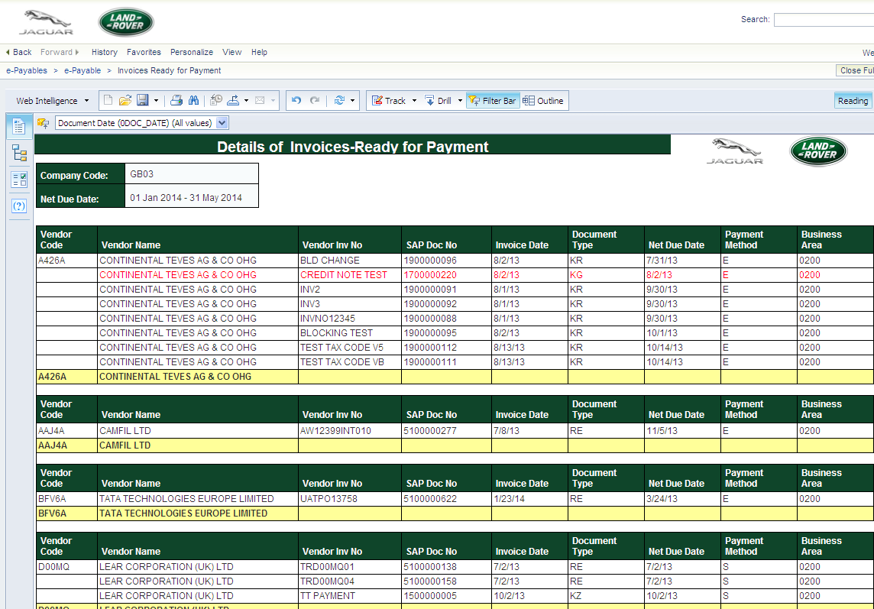
3 | A toolbar is displayed at the top of the report.  Details of the key buttons are listed below.  Select an action from the following:  If you want to… then …  Print the report (Opens in a PDF format) Click The PDF file displays Click to print  Export the report in PDF or Excel format Click Click Export Document As Choose the relevant file type Click Open to view the document The document can be saved locally if required  Export the report in Excel CSV format Click Click Export Data to CSV Click OK The document can be saved locally if required  Refresh the report to change the Prompts that you entered on the initial screen Click to refresh Update the Prompts screen as required Click (Refer to the document: How Do I Access Reports in the Supplier Self Service (SUS) Portal, for full information on entering Prompt data.)  Filter information in the report, e.g. by date Click A new toolbar is displayed at the top of the report: Click the filter icon in the toolbar A new menu is displayed underneath the toolbar - Click A list of options is displayed: Select the option that you want to filter on, e.g. Document Date. A new box is shown in the filter toolbar at the top of the report: Click on the drop-down arrow and select the value that you want to filter on Your report is updated to show only the selected value. (To remove the filter, click back in the box and select [All Values] from the list).  Undo the last change to your report Click to undo  View the left hand Navigation Pane so you can change the report you are viewing (If you previously clicked the Full Screen button, then click Close Full Screen). Click to open the Navigation Pane.  Exit the Supplier Self Service Portal Click Log Off at the top right of the screen.  Understand the column headings in the report Refer to the definitions in the tables at the end of this document.

Report Contents: Column Headings Terms and Definitions
Please refer to the tables below for definitions of the data shown in the reports.

Debit Note Report:
Column Heading | Definition
Vendor Code | This is JLR's unique reference number for a Vendor
Vendor Name | This is the Vendor name
Debit Note Date | Date on which the Debit Note was created
Debit Note No | Unique identifying reference number for the Debit Note
Document Type | Type of Debit Note (code), e.g. KG (Vendor Credit Memo), ZE (ERES Invoice)
Document Description | Type of Debit Note (description)
Status | Shows our Clearing (Payment) document number
Clearing Document | Shows our Clearing (Payment) document number
Document Value | Debit Note value
Document Currency | Debit Note currency

Invoices Ready for Payment (was SRM Outstanding Payment Report): Summary of invoices-Ready for Payment (was Total Outstanding Summary) Tab
Column Heading | Definition
Net Due Range < [date] | Shows the amount of any payments due before the Due Date 1 that you entered in the Prompts screen
Net Due Range <> [date] - [date] | Shows the amount of any payments due between the Due Dates 1 and 2 that you entered in the Prompts screen.
Net Due Range > [date] | Shows the amount of any payments due after the Due Date 2 that you entered in the Prompts screen

Invoices Ready for Payment (was SRM Outstanding Payment Report): Details of Invoices-Ready for Payment (was Details of Outstanding Payments) Tab
Column Heading | Definition
Vendor Code | This is JLR's unique reference number for a Vendor
Vendor Name | This is the Vendor's company name
Vendor Inv No | Vendor's own invoice reference number
SAP Doc No | JLR's SAP document number which is generated when we process your invoice
Invoice Date | Date on which the invoice was raised by the vendor
Document Type | Code which identifies the type of invoice document created in the SAP system, e.g. KR (Vendor Invoice), KS (Self Billing Invoice), RE (Purchase Order related invoice)
Net Due Date | Date on which the invoice amount becomes payable
Payment Method | Method of payment used for this invoice, e.g. E (Electronic Funds Transfer) T (Telegraphic Transfer Order, C (Cheque)
Business Area | Identifies which JLR business area the invoice was raised against, e.g. 0100 (Land Rover), 0200 (Jaguar), 0300 (EMC)
Amount DC | Amount of invoice in the currency denoted on the invoice document
Doc Curr | Currency denoted on the invoice document
Amount LC | Amount of invoice in local currency
Local Currency | Local currency used

Payment History Report (was SRM Payment History Report): Paid Invoices (was Payment History) Tab
Column Heading | Definition
Payment Document No | JLR's unique number to identify this payment (you can click on this to view the Payment Advice)
Payment Issue Date (Net Due Date) | Date on which payment was issued
Vendor Code | This is JLR's unique reference number for a Vendor
Vendor Name | This is the Vendor's company name
Gross Amount | Invoice amount including VAT
Currency | Payment currency
Business Area | Identifies which JLR business area the invoice was raised against, e.g. 0100 (Land Rover), 0200 (Jaguar), 0300 (EMC)
Payment Method | Method of payment used for this payment, e.g. E (Electronic Funds Transfer) T (Telegraphic Transfer Order, C (Cheque)

Payment History Report (was SRM Payment History Report): Details of Paid Invoices (was Detailed Payment) Tab
Column Heading | Definition
Accounting Document No | JLR's unique number to identify this payment (you can click on this to view the Payment Advice)
Payment Document No | JLR's unique number to identify this payment
Vendor Code | This is JLR's unique reference number for a Vendor
Vendor Name | This is the Vendor's company name
Business Area | Identifies which JLR business area the invoice was raised against, e.g. 0100 (Land Rover), 0200 (Jaguar), 0300 (EMC)
Document Date | Date on which payment was issued
Document Type | Identifies the type of document, e.g. Payment Posting
SAP Invoice No | JLR's unique invoice reference number
Gross Amount | Amount paid including VAT
Deductions | Details the value of any deductions made from this payment
Currency | Payment currency
Payment Method | Method of payment used for this payment, e.g. E (Electronic Funds Transfer) T (Telegraphic Transfer Order), C (Cheque)
Net Due Date | Date on which payment was issued

Invoices Pending In-Progress: Details of Invoices Pending in-Progress tab
Column Heading | Definition
Vendor Invoice No | Vendor's own invoice reference number
Invoice Status
Approver's CDSID | User ID of the JLR approver of the invoice
Approver's Name | Name of the JLR approver of the invoice
Approver's Email | Email of the JLR approver of the invoice
Vendor ID | JLR's unique reference number for a Vendor
Vendor Name | Vendor's company name
Purchasing Doc | JLR's SAP Purchase Order number which is generated when we create your Purchase Order
Legacy PO | JLR's Legacy Purchase Order number which was generated when we created your Purchase Order prior to SAP implementation
Invoice Date | Date listed on the Invoice
Net Due Date | Date on which the invoice amount becomes payable
Net Amount | Amount to be paid excluding VAT
Total Amount
Currency | Payment currency
Invoice Identifier | JLR's unique number to identify this invoice within the invoice scanning system

