JAGUAR LAND ROVER LIMITED
Supplier Technical Assistance

Covisint Access
and Document Location User Guide

Table of Contents

Page | Title
3 | How to access Covisint and Register / Login?
4 | How to Login
5 | questions or queries
6 | How to find documents in Covisint

How to access Covisint and Register / Login?

- Follow the link: Covisint
- Click on “register with Covisint”
- Follow the step by step guidelines on Covisint (this will be shown on Covisint)
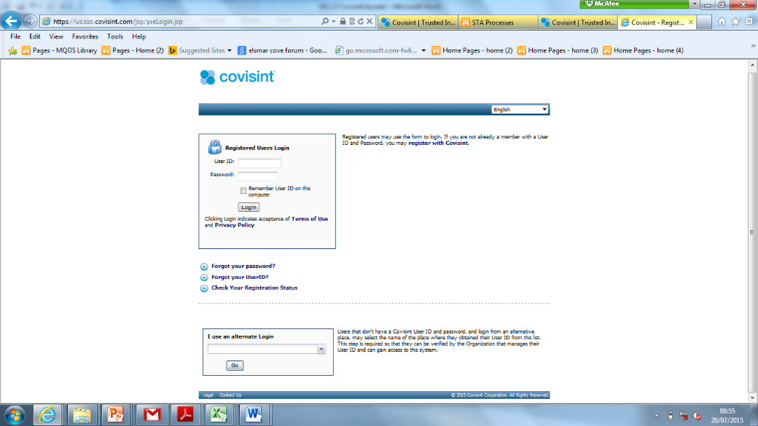

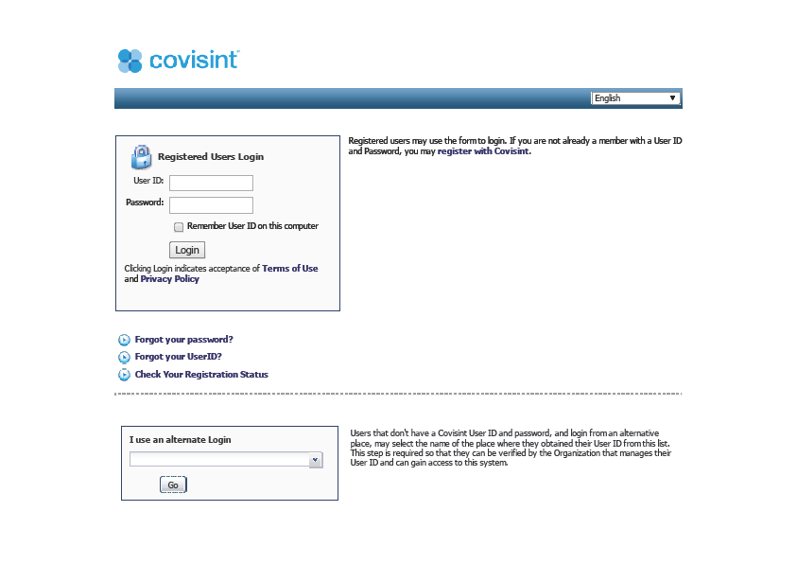

How to Login

Once Registered -

- Click on “User ID” & enter your User ID
- Click on “Password” & enter your Password
- Click “Login”
- Go to the Automotive Portals and click Jaguar Landrover Portal

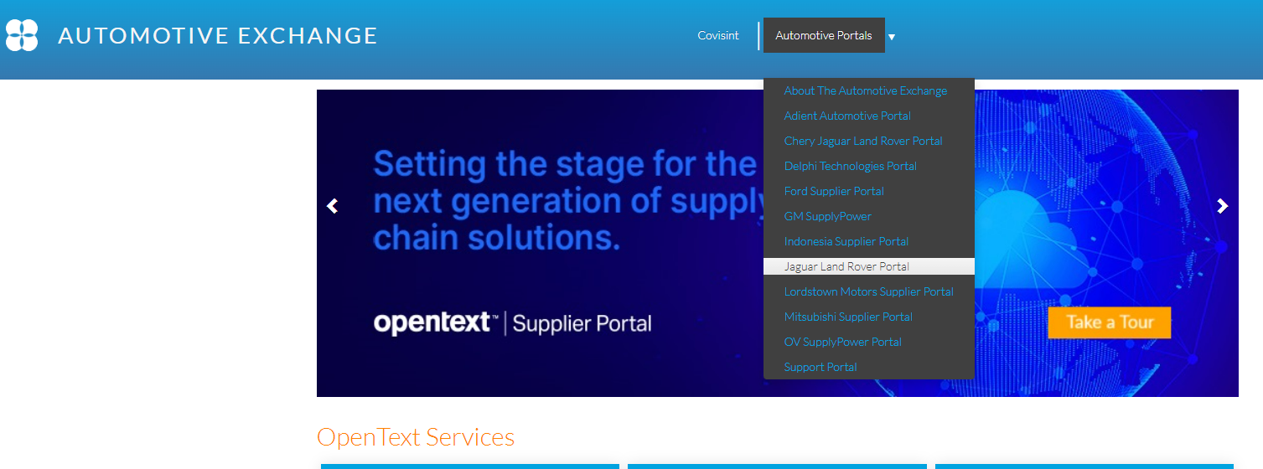

JLR Homepage should appear

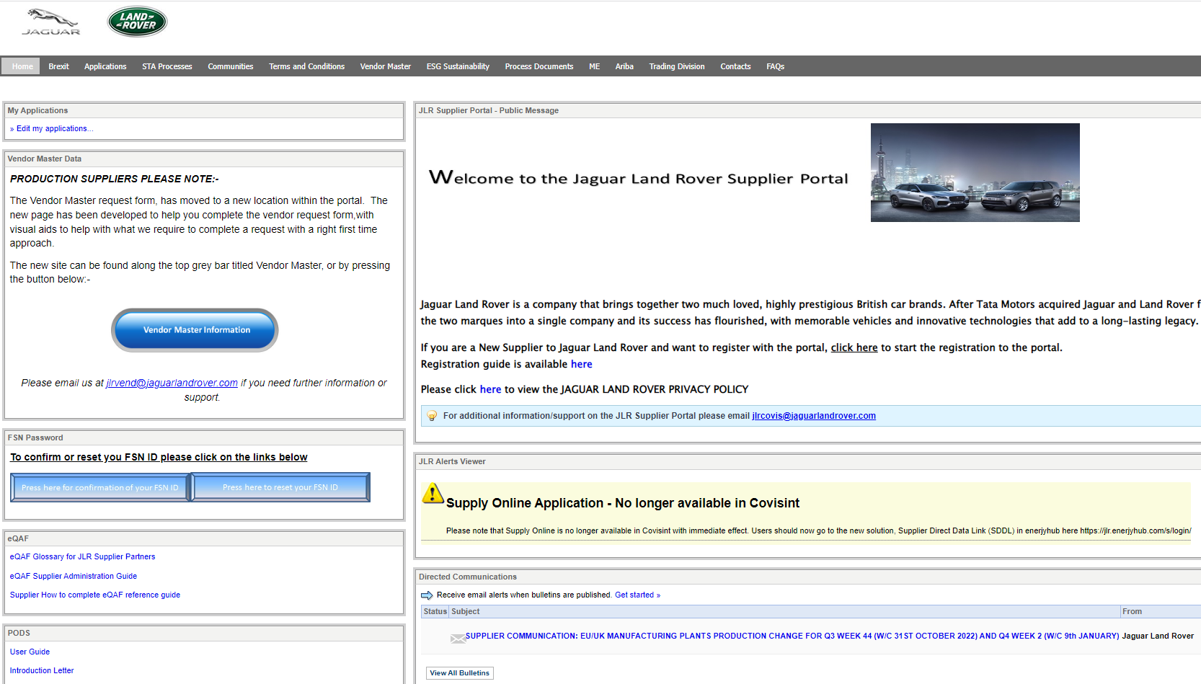

Questions or Queries

- Click on “Contacts’ for any help or support.

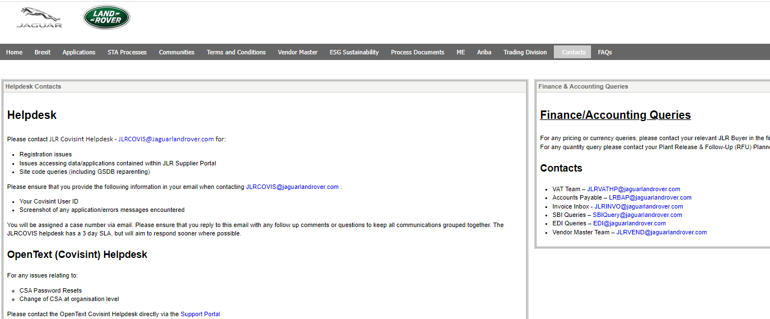

How to find documents in Covisint

Once access to Covisint has been obtained, and you are in the JLR Portal:
- Click on ‘STA Processes’
- Review Process based on your area of interest on the left hand of the screen
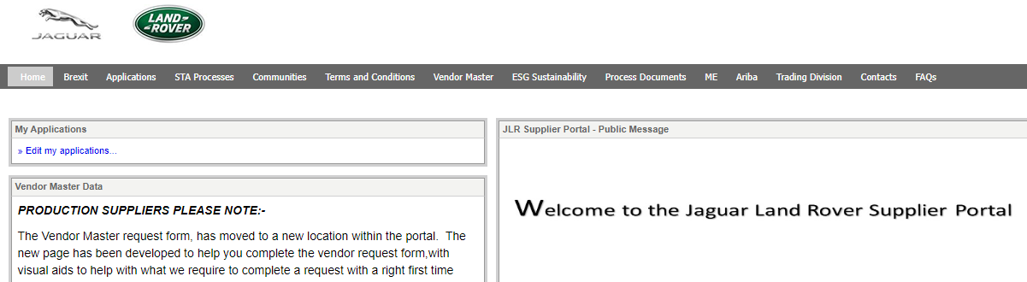
- Select the documents you are looking for – it will then download for you
2.
1.
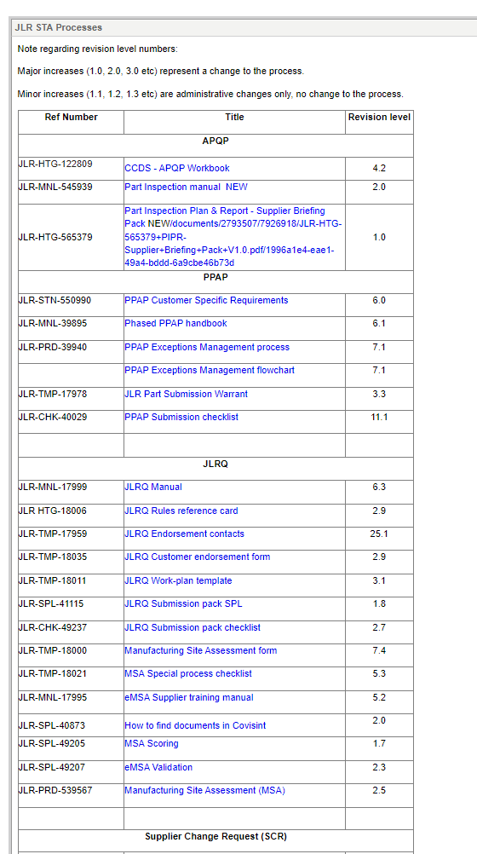

3.
Click on the Document Title, this will then download

